New Brunswick is rich in beautiful lakes, rivers and streams. New Brunswickers value this beautiful natural heritage and worry that the health of our water and our people is at risk from too much pollution. At the same time, New Brunswickers do not perceive themselves as big players in water protection and have yet to adequately prepare for climate change related risks like flooding.
This complex picture of our relationship to water emerges from a comprehensive 2016 online survey of 502 residents conducted for the Conservation Council by Corporate Research Associates. The survey was developed using a national survey of attitudes toward fresh water conducted by the Royal Bank of Canada (RBC) in 2016. Organizations reporting national survey results generally combine results for all Maritime provinces in their data analysis is based on small numbers of regional respondents. The Conservation Council, with this survey, corrects for these flaws and establishes a comprehensive provincial baseline on fresh water and emergency preparedness that can credibly be compared to national results.

Topline results
Figures 1 and 2 graphically summarize how New Brunswickers feel about their lakes, rivers and streams. When we asked New Brunswickers to tell us what they love about their favourite lake, river or stream, the most cited word was “clean” followed by “beauty”. When we asked New Brunswickers to tell us what worries them about their favourite lake, river or stream, the most cited word was “pollution” and other associated words like “contamination”.
It should come as no surprise given this strong desire for clean, healthy water, that a strong majority of survey respondents (over 80% agree/strongly agree) want government to establish stronger rules for industrial water use and to require industry to obtain a licence for water use. In addition, survey respondents believe that companies should pay the full cost of the water they use (75%), should report water use (along with municipalities, 77%), and that decisions about how water should be treated should be based on sound science (76%). As is often the case, however, New Brunswickers do not want consumers to pay the full cost of using water (48% agree/strongly agree) or to be charged for the full cost of water use (26%). These results are not unusual, but do suggest the need for ongoing citizen education about the value of water conservation for households, as well as industry and municipalities.
New Brunswick residents experience boil water orders at a far higher rate than the national average with 44% of survey respondents saying they have experienced a boil water order, compared to national results of 24% in the RBC survey. Seventy-five percent of survey respondents from Saint John (n = 69) say they have experienced a boil water order and are more inclined to say they are not very confident about the quality of the water in their home (19%, compared to 11% provincially).
Overall, New Brunswickers say they are moderately confident in the quality of the water in their home (39%), with 21% being very confident, and 25% somewhat confident. It is not surprising given the high exposure to boil water orders and moderate confidence levels, that citizens want governments to invest in infrastructure to improve drinking water supplies (92%), water treatment (91%), sewage treatment (86%), and to prevent boil water orders (83%).
Important, but less so compared to water quality related infrastructure, is spending on storm water management (67%) and investments to protect against extreme weather and flooding (71%).
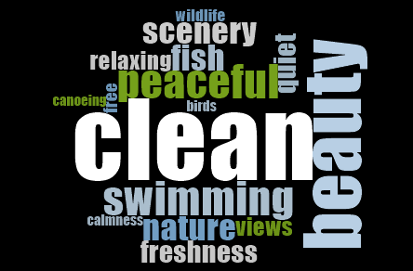
What do you Love most about your favourite lake, river or stream?
Figure 1. Keep our water clean
Word cloud results to question: What do you love most about your favourite lake, river or stream?

What worries you most about your favourite lake, river or stream?
Figure 2. Keep pollution out of our water
Word cloud results to question: What do you worry most about your favourite lake, river or stream?
We also asked respondents, in a closed-ended question, to indicate how concerned they are about the quality of the water in the lakes, rivers or streams they swim in. Thirty-six percent are somewhat concerned, 19% are concerned, and 21% are very concerned, bringing total concern to 76%.
While clean water clearly is a health and natural resource concern for New Brunswickers, there is less awareness of the water-related impacts and risks associated with a changing climate. Seventy-seven percent of respondents believe they are not at risk of flooding or drought, with only 28% believing that their family is likely or very likely at risk of flooding; 36% believe the same about post-tropical storms or hurricanes. When asked if they are worried about a range of extreme weather events, respondents showed low levels of worry, with 21% worried or very worried about floods; 21% about post-tropical storms and hurricanes; 12% drought; and 34% ice and hail storms.

http://www.rbc.com/community-sustainability/_assets-custom/pdf/CWAS-2016-report.pdf

